DAY 3 [08-01-2026]
Assignment: to create a document for the topic publishing with proper screenshots and arrow indication of how to publish etc. in self-contained and dependent mode.

Publishing means preparing your application for deployment so it can run on a target machine (user system, server, or cloud) outside Visual Studio.
When you publish a .NET application, Visual Studio (or the .NET CLI) compiles the code and produces files that can be copied and executed on another machine.
Why Publishing Is Required
- To run the application on another computer
- To deploy on a server (IIS, Linux server, Windows service)
- To upload to cloud platforms (Azure, AWS, etc.)
- To share the application with users
Steps for Publishing (Using Visual Studio)
Step 1: Create a New Project
- Open Visual Studio
- Click Create a new project
- Select a project type (e.g., Console App, Windows Forms App, ASP.NET Core Web App)
- Click Next
- Enter Project Name and Location
- Click Create
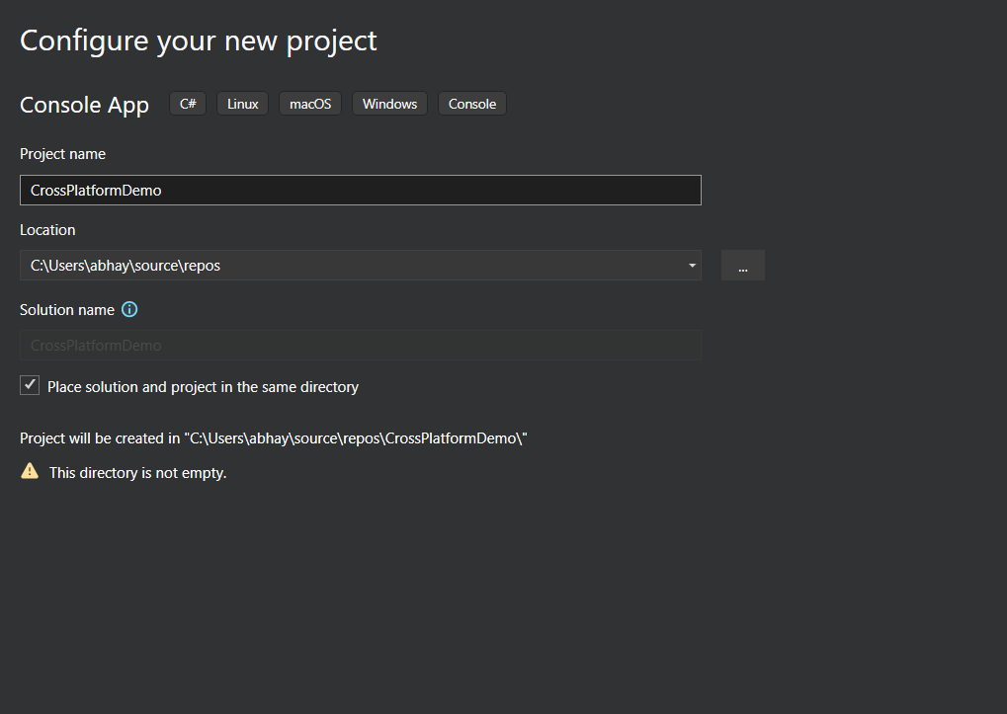
Screenshot 1: configuring your project
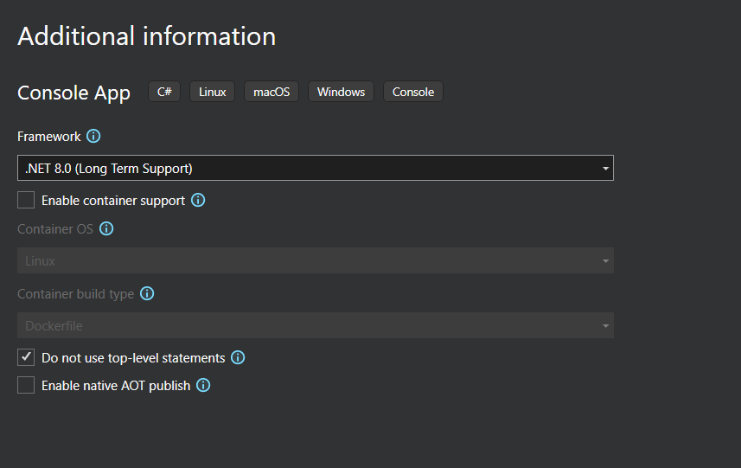
Screenshot 2: configuring your project
Step 2: Write the Code
- After the project is created, Visual Studio opens the default code file
- Write the required application code
- Save the file using Ctrl + S

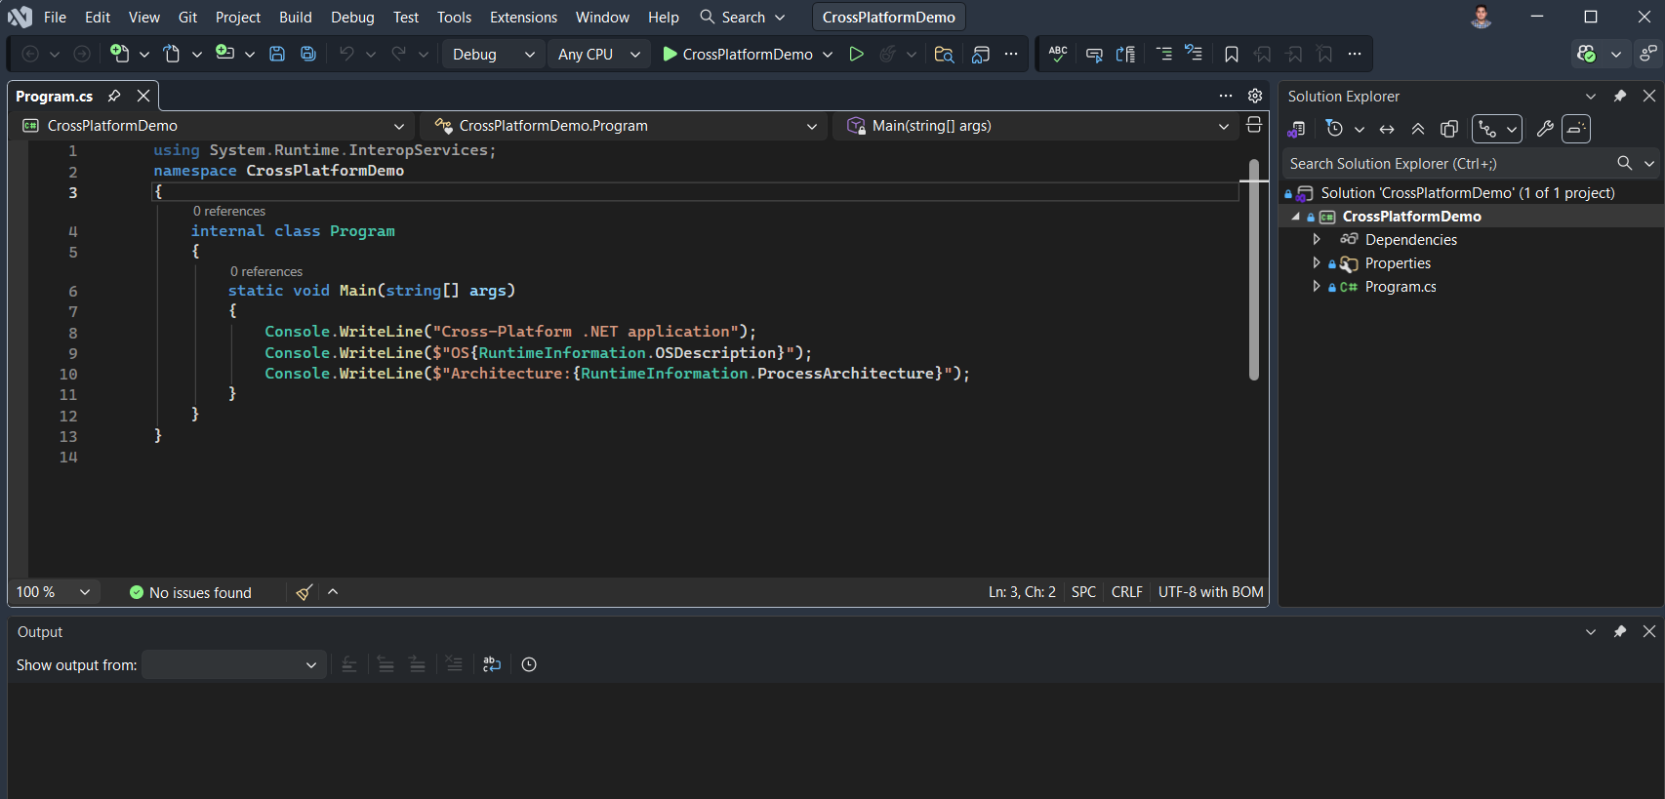
Screenshot 3: write your code
Step 3: Open the Created Project in Solution Explorer
- Ensure Solution Explorer is visible
- Verify that all project files are loaded correctly

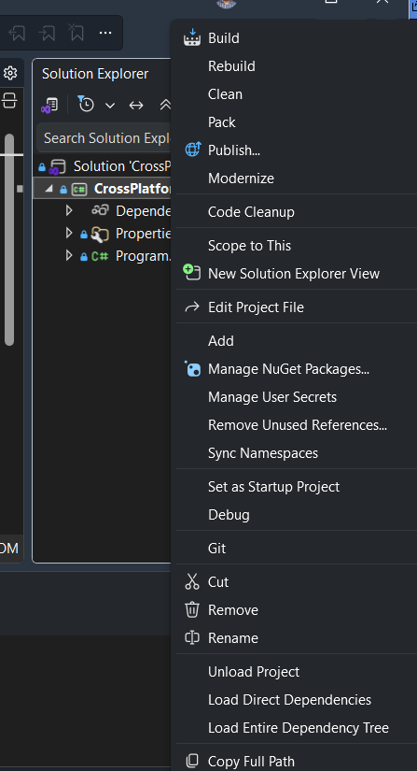
Screenshot 4: right click on the project in solution explorer
Step 4: Choose Publishing Target
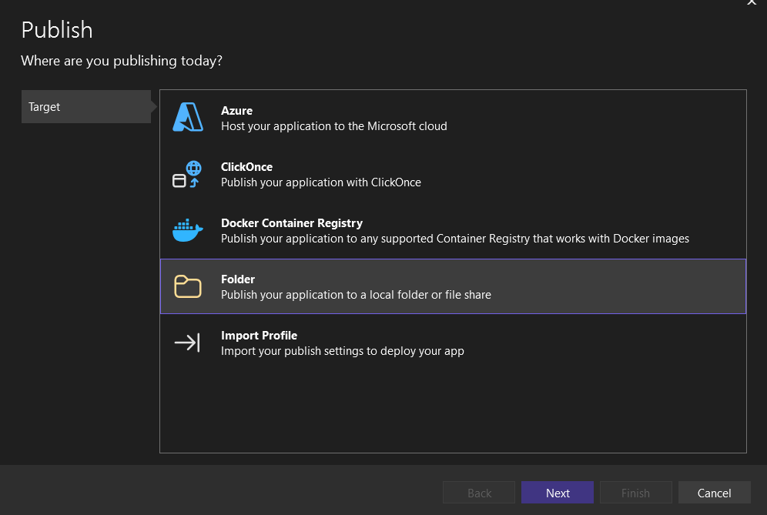
Screenshot 5: Target selection screen

Step 5: Choose Folder Location
- Select a local folder where published files will be stored
- Click Finish
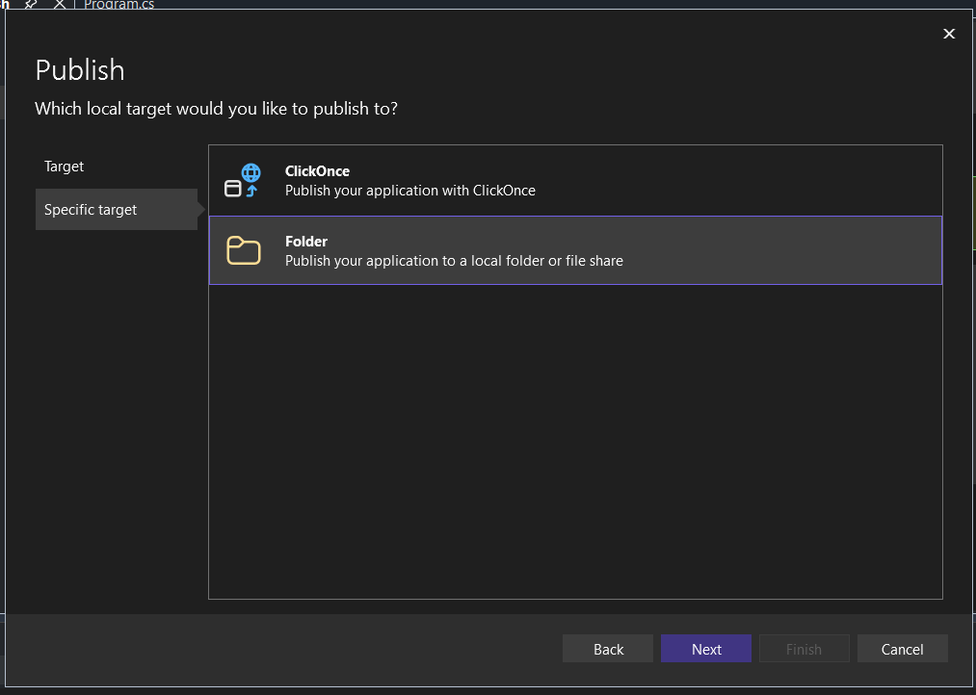
Screenshot 6: Folder selection dialog
Step 5: Click Publish
- Click the Publish button
- Visual Studio builds and copies files to the selected folder
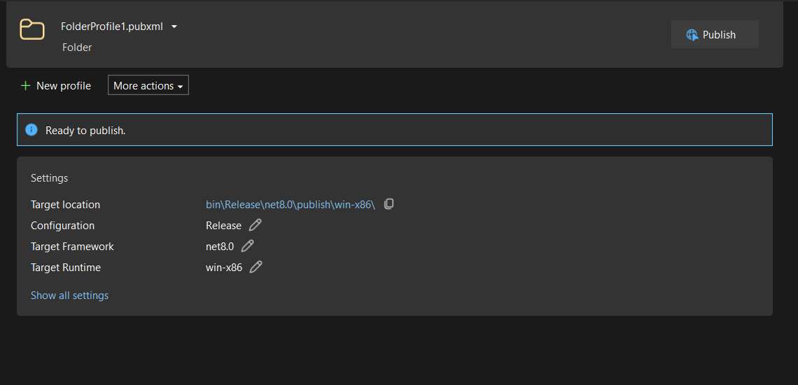
Screenshot 6: Publish window

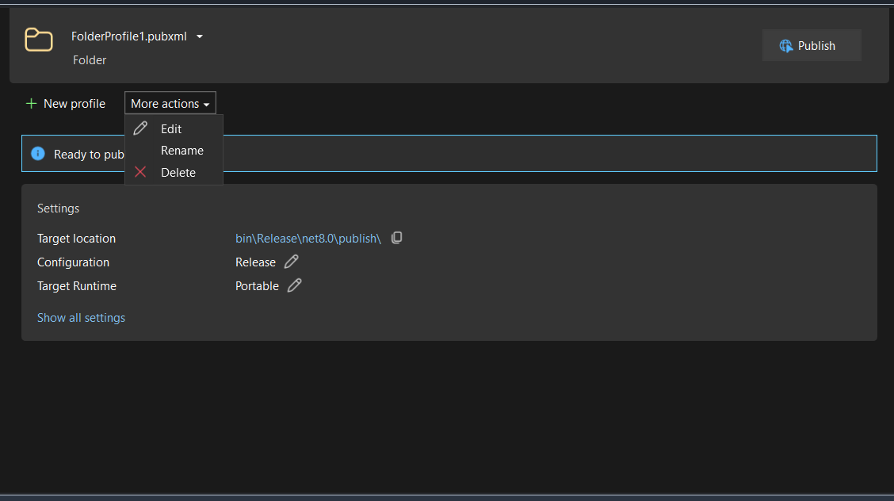
Screenshot 7: Publish edit options

Publish Modes in .NET
1. Framework-Dependent Deployment (FDD)
Meaning:
- The application depends on .NET runtime installed on the target machine
- Smaller output size
Characteristics:
- Requires .NET runtime on target machine
- Portable across machines with same OS
Example Use:
- Corporate systems where .NET is already installed
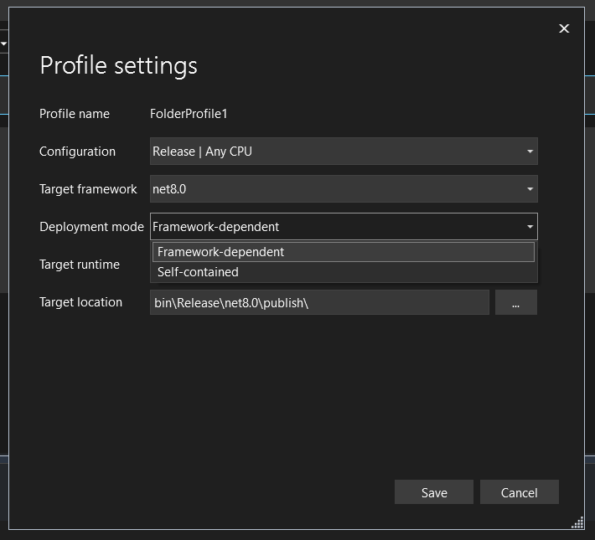
Screenshot 9: Framework-Dependent Deployment (FDD) and Self-Contained Deployment (SCD)
Options while publishing.

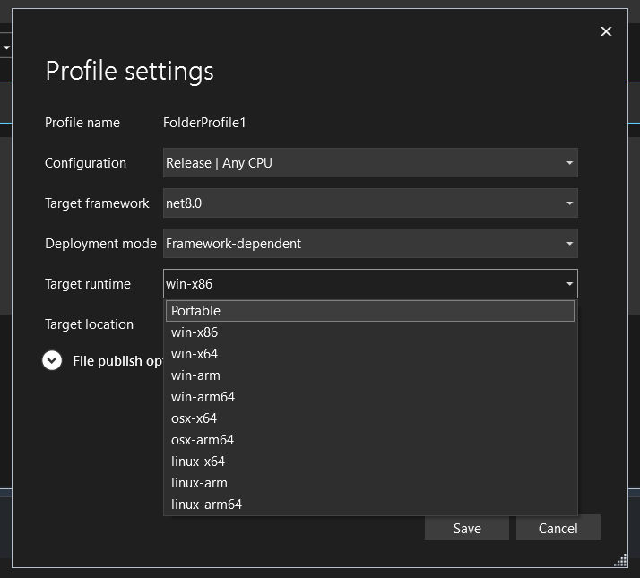
Screenshot 10: Framework-Dependent Deployment (FDD)

2. Self-Contained Deployment (SCD)
Meaning:
- Application includes .NET runtime inside itself
- Does NOT require .NET to be installed
Characteristics:
- Larger file size
- Runs independently
Example Use:
- End-user systems
- Offline machines
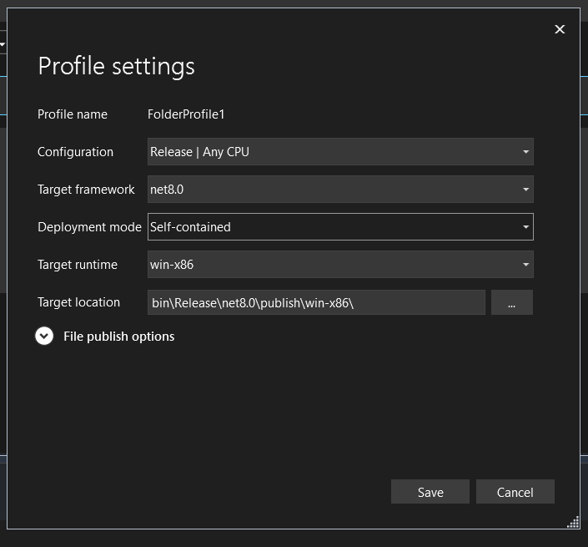
Screenshot 11: Self-Contained Deployment (SCD)

3. Portable Deployment
Meaning:
- Application can run on any machine of the same OS architecture
- Usually framework-dependent
Characteristics:
- Needs runtime installed
- Easy to share
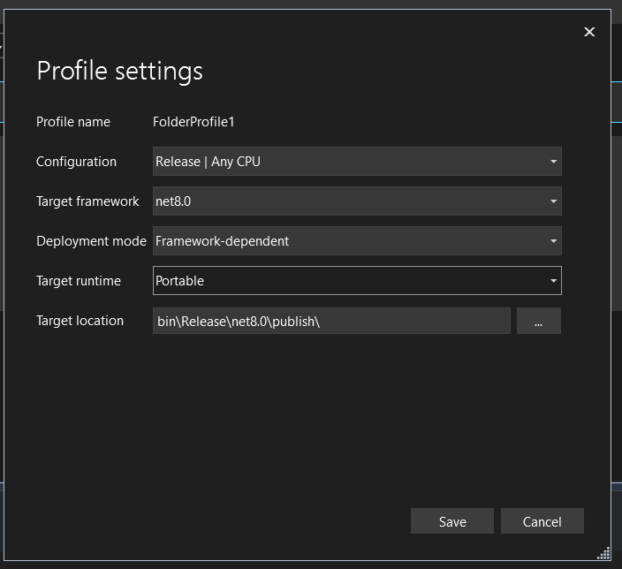
Screenshot 12: Portable Deployment
Final Step: Click Publish
- Click the Publish button
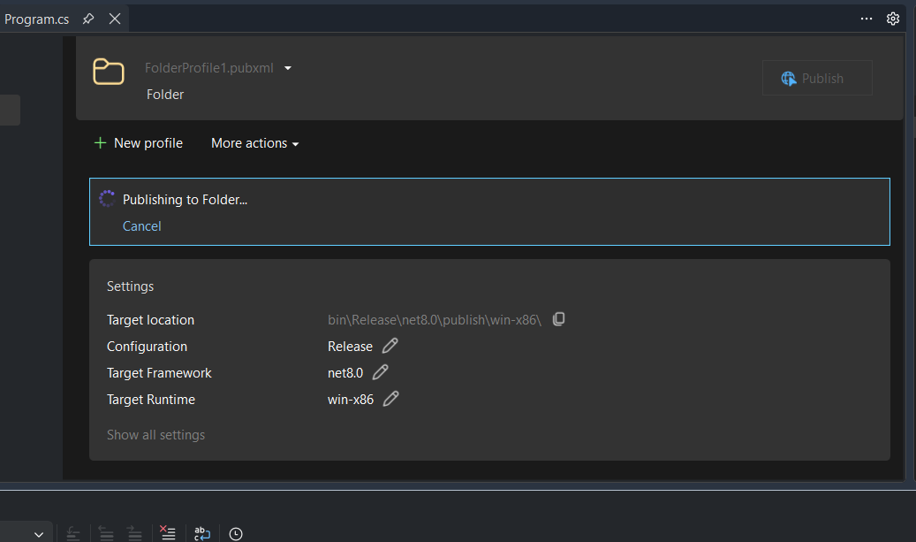
Screenshot 13: Publishing starts after clicking publish button

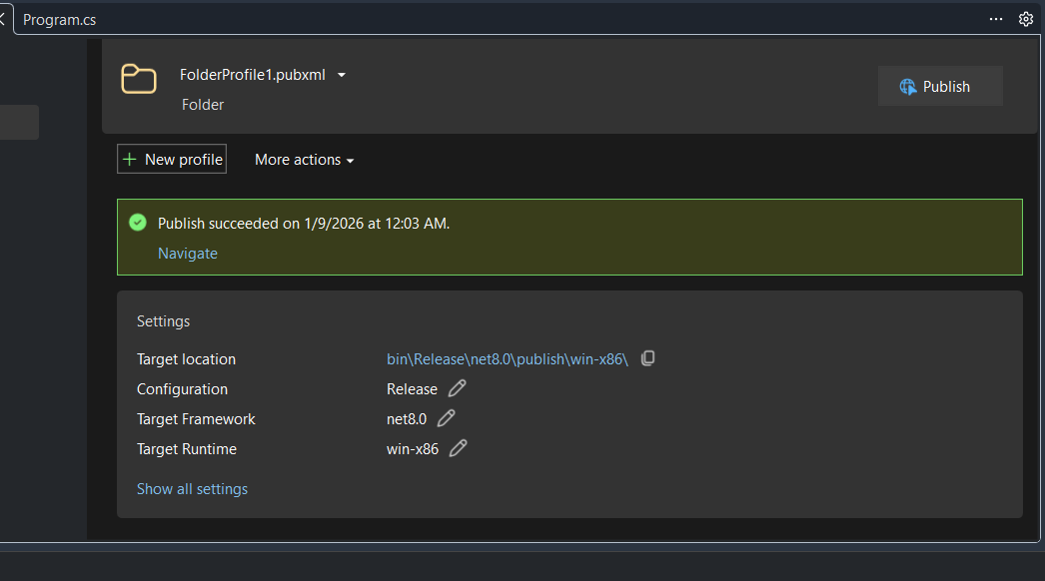
Screenshot 14: Publishing succeeded

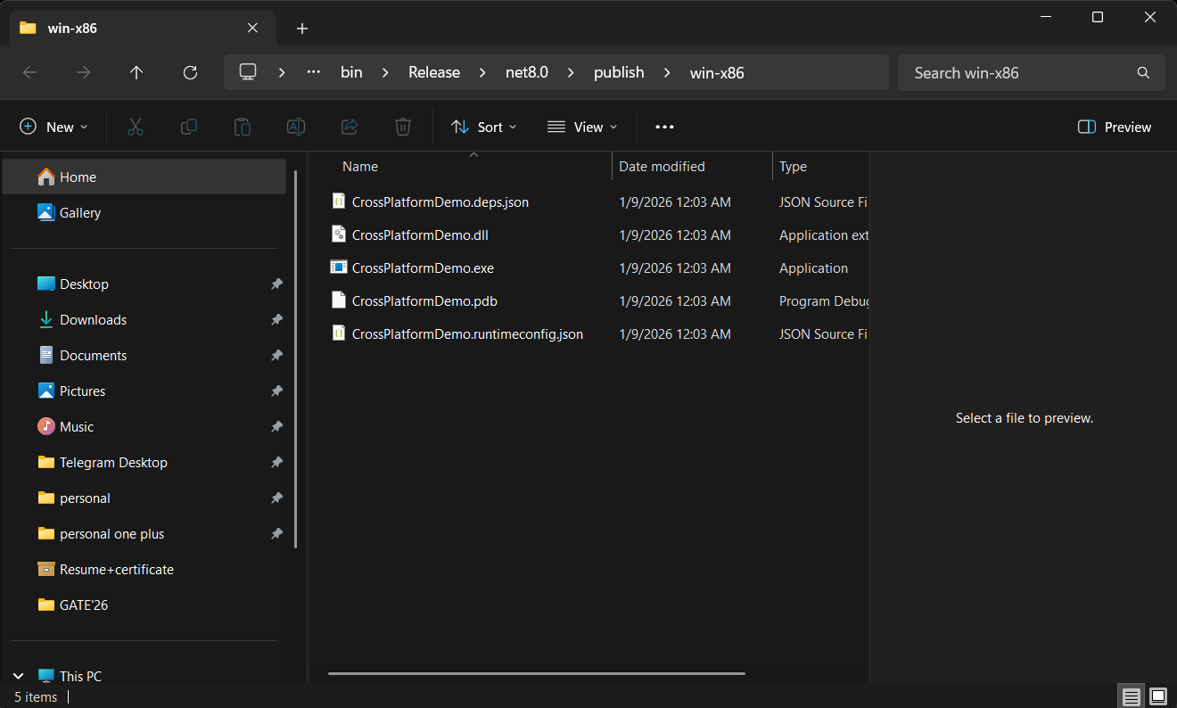
Screenshot 15: Navigation of the Published Project

